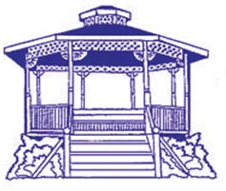
CITY OF PASS CHRISTIAN
HISTORICAL PRESERVATION MEETING
REGULAR MEETING AGENDA
AGENDA
August 13, 2025

CANCELED MEETING

PUBLIC NOTICE is hereby given that the City of Pass Christian will not hold a Public Meeting on August 13, 2025 at 6:00 P.M.

**Meeting Canceled**

POSTED on this 8th^{th} Day of August, 2025
Melodie Hayes, City Planner

